PM-04-PS02
Automation Design & Implementation
Robotic Process Automation Solution

ASSESSMENT EVIDENCE PACKAGE

https://github.com/TheFish1011/PM-04-PS02.git
Author | Estian Visagie
Course Code | PM-04-PS02
Document Version | v1.0
Submission Date | 27 April 2026

1. Purpose of this document
This document provides the design, implementation, and execution evidence for the MzansiConnect Customer Onboarding automation. The solution automates the onboarding of customer records from a CSV file into a CRM system, including validation, logging, and exception handling.
This document maps to the following assessment criteria:
• PA0201 – Decide Bot Steps
• PA0202 – Logging Behaviour
• PA0203 – Exception Handling
• IAC0201 – Reusability
• IAC0202 – Logging & PII Handling
• IAC0203 – Exception Handling Validation

2. Process Analysis and Bot Steps (PA0201)

2.1 Overview
- Start process and log execution start time
- Read customer data from CSV file
- Create exceptions tracking table
- Loop through each customer record
- Validate data fields (SA ID and Phone Number)
- Process valid records into CRM
- Log outcomes for each record
- Generate summary and exception report
- End process

2.2 Detailed Sequential Steps
- Open CSV file containing customer data
- Load data into DataTable
- Open CRM system (simulated in this implementation)
- For each customer record:
  - Extract Name, Surname, SA ID, Phone Number
  - Validate SA ID presence
  - Validate Phone Number format
  - If valid:
    - Submit data to CRM
    - Log success
  - If invalid:
    - Log failure
    - Store in exception report
  - Generate summary report
  - Save exception report to CSV
  - Log process completion

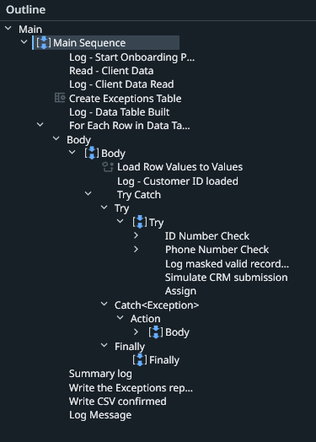

3. Logging Behaviour (PA0202 & IAC0202)

3.1 Information Logged
- Process start and end timestamps
- Total records processed
- Per-record processing status
- Validation failures
- System exceptions
- Final summary (Success / Skipped / Total)

3.2 PII Identification and Handling
PII Fields:
- Name
- Surname
- SA ID Number
- Phone Number

Handling Approach:
- SA ID and Phone Number are masked in logs
- Name and Surname are not logged
- Logs reference only CustomerID and masked values

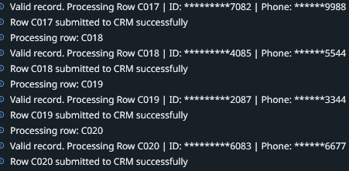

4. Exception Handling (PA0203 & IAC0203)
Scenario A: Missing SA ID
- Exception Type: Business Exception
- Handling: Log, add to exception table, increment skip counter, continue
Scenario B: CRM System Unavailable
- Exception Type: System Exception
- Handling: Try-Catch, log error, add to exception table

Scenario C: Invalid Phone Number
- Exception Type: Business Exception
- Handling: Clean with Regex, validate, log, add to exception table, skip

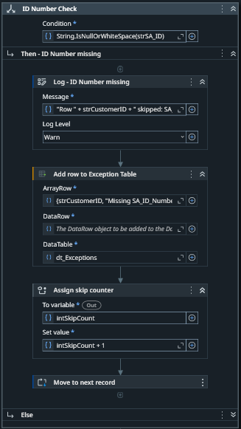
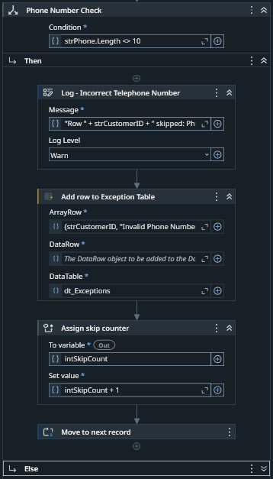
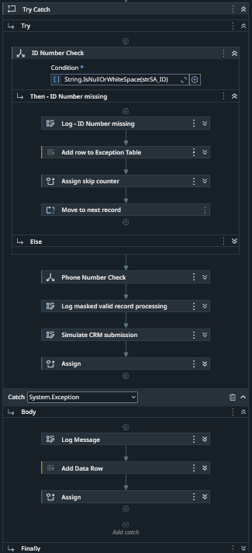

5. Reusability (IAC0201)
Note
This workflow was not created this section just covers what could be done.
Description:
Reusable workflow to submit validated customer data to CRM.
Input Arguments:
- Name
- Surname
- SA ID
- Phone Number

Output Arguments:
- Success Status
- Error Message
Pre-Conditions:
- CRM accessible
- Data validated
Post-Conditions:
- Customer added OR error returned

6. Solution Development (Task 5)
Implementation uses UiPath Studio with Read CSV, For Each Row, If conditions, Regex cleaning, Try-Catch, and Write CSV.
Scripting used:
Regex.Replace(value, "[^0-9]", "")
Operating System considerations include file paths and selector differences.

7. Execution Results
Final test run:
Success: 18 | Skipped: 2 | Total: 20
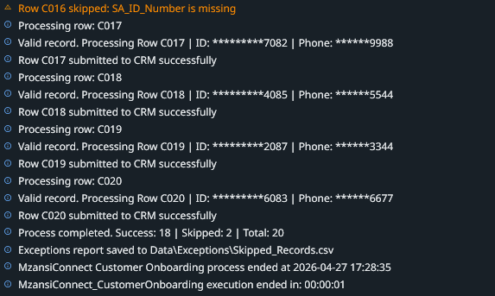

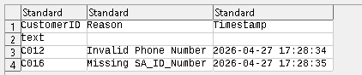

8.Conclusion
The automation meets all requirements including validation, exception handling, logging, and reusable design.

